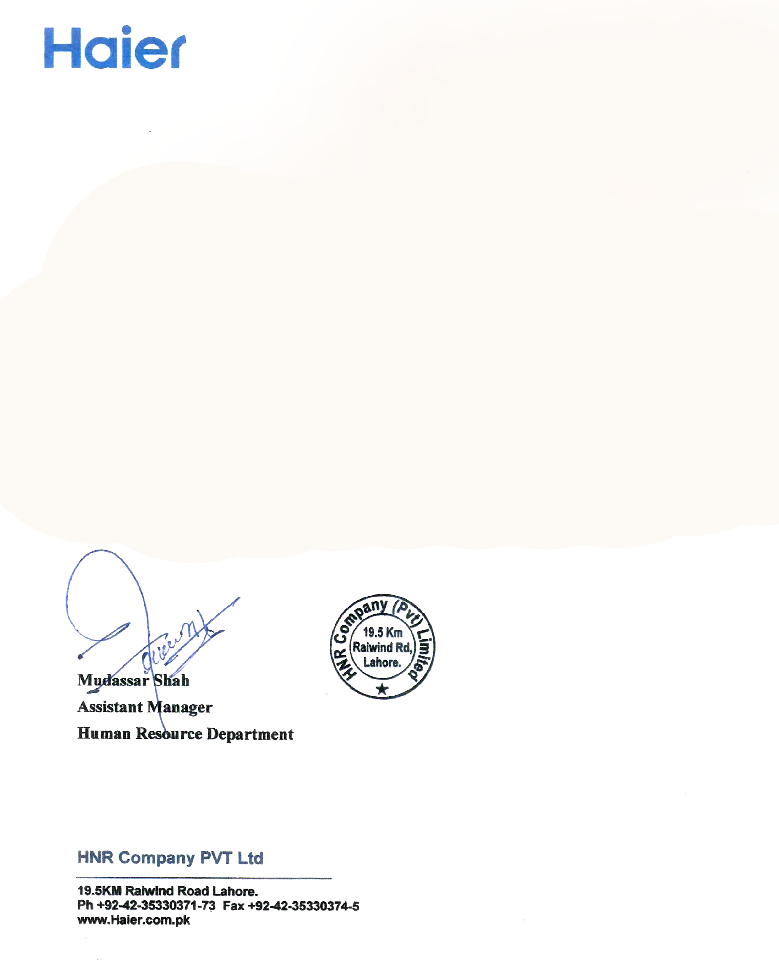

**HNR/HR/EXP/1020**

**Dated: <To>**

**To Whom It May Concern**

This is to certify that Mr. <Name> S/O <fname> has worked as <Designation> at HNR Company Pvt. Ltd. Lahore, from <From> to <To>.

During his stay with us we found him hard working, honest and dedicated. He shows exemplary performance, professional behavior and utmost dedication to his work.

We wish him best of luck for his future endeavors.